PROJECT FINAL REPORT

Plugging Into the Future:
An Exploration of Electricity Consumption Patterns
A Data Analytics and Visualization Project using Tableau
Team Members
Dharshini Priya S
Thanusha Peneti
Yogananda Reddy Chinnannagari
Mudiyala Shashank Reddy
GitHub Repository
github.com/Dharshini025/An-Exploration-of-Electricity-Consumption-Patterns

Table of Contents

Introduction

Ideation Phase

Requirement Analysis

Project Design

Project Planning & Scheduling

Functional and Performance Testing

Results

Advantages & Disadvantages

Conclusion

Future Scope

Appendix

1. Introduction

1.1 Project Overview
"Plugging into the Future: An Exploration of Electricity Consumption Patterns" is a data analytics and visualization project focused on uncovering trends, seasonal variations, and regional differences in electricity usage. As energy demand continues to grow with urbanization, industrial expansion, and climate variability, there is a pressing need for utilities, regulators, and consumers to understand how, when, and where electricity is consumed.
This project uses Tableau to design interactive dashboards that analyze electricity consumption across multiple dimensions, including monthly and seasonal trends, state/region-wise demand, peak versus off-peak usage, and year-over-year growth. These visualizations enable users such as energy analysts, utility planners, policy makers, and sustainability teams to identify consumption patterns, anticipate demand spikes, and support grid planning decisions.
By converting raw electricity consumption records into clear, interactive visual stories, the project bridges the gap between data and decision-making. It allows stakeholders to respond quickly to shifts in demand, plan infrastructure investments, and promote more efficient and sustainable energy use.
The project also demonstrates the practical use of data visualization tools in the energy sector, showing how a well-designed dashboard can simplify complex time-series and geographic datasets into insights that are easy to interpret and act on.

1.2 Purpose
The primary purpose of this project is to analyze electricity consumption data and transform it into interactive, visual insights using Tableau. With rising energy demand and the growing push toward renewable integration and grid modernization, understanding consumption behavior is critical for utilities and policy makers aiming to balance supply, reduce wastage, and plan for the future.
This project is intended to serve as a decision-support system that empowers stakeholders — including grid operators, energy analysts, and government bodies — to explore and interpret data across dimensions such as monthly consumption trends, regional/state-wise demand, seasonal peaks, and year-on-year growth. These insights help stakeholders make informed decisions based on patterns, trends, and correlations found in the data.
Beyond decision-making, the project also aims to:
- Improve accessibility to complex electricity consumption datasets through simple, interactive visual dashboards.
- Support demand forecasting and grid capacity planning by identifying seasonal and regional consumption patterns.
- Enable faster responses to unusual spikes or drops in electricity demand.
- Demonstrate the effective use of data visualization tools (Tableau) in solving real-world energy management challenges.
In summary, the project aims to bridge the gap between raw electricity data and actionable insight, helping utilities and energy stakeholders remain proactive, efficient, and data-driven.

2. Ideation Phase

2.1 Problem Statement
A well-articulated problem statement helps the project team focus on what matters most to stakeholders and identify the ideal solution for the challenges they face when interpreting electricity consumption data.
PS | I am (Customer) | I'm trying to | But | Because | Which makes me feel
PS-1 | A grid operations analyst | Anticipate monthly demand spikes across regions | Can't easily see seasonal patterns | Consumption data is scattered across raw spreadsheets | Overwhelmed
PS-2 | A policy researcher | Compare electricity usage across states | Can't compare regions side by side | No unified visual dashboard exists | Frustrated

2.2 Empathy Map Canvas
An empathy map captures knowledge about the user's behaviours and attitudes toward electricity consumption data, helping the team design a dashboard that genuinely fits their needs.
Quadrant | Details
Think & Feel | Concern over rising energy costs  Pressure to forecast demand accurately
See | Raw consumption spreadsheets  Government energy reports and news
Hear | Discussions on peak load management  Renewable integration debates
Say & Do | Request clearer regional comparisons  Share feedback on grid strain
Pain | Fragmented data sources  Difficulty spotting seasonal trends
Gain | Faster, evidence-based planning  Reduced blackout / overload risk

2.3 Brainstorming
Brainstorming provides a free and open environment that encourages every team member to contribute ideas toward solving the problem of interpreting electricity consumption data. Prioritizing volume over value, all ideas are welcomed and refined collaboratively.
Step 1: Team Gathering and Problem Selection
The team reviewed the available consumption dataset and selected "lack of visual insight into monthly and regional electricity demand" as the core problem to address.
Step 2: Idea Listing and Grouping
- Visualize monthly electricity consumption trends over time using line charts.
- Create interactive dashboards showing state/region-wise demand using maps and heatmaps.
- Highlight seasonal peaks (summer/winter) using time-series charts.
- Compare year-over-year growth using bar and area charts.
- Design a filterable view to compare consumption by state, month, and year.
- Build a story to walk stakeholders through key findings step by step.
Step 3: Idea Prioritization
Ideas were plotted on an importance-versus-feasibility grid. High-importance, high-feasibility ideas selected for the MVP included: monthly trend line charts, state-wise heatmaps, and a filterable comparison dashboard. Lower-priority ideas such as predictive forecasting were deferred to future scope.

3. Requirement Analysis

3.1 Customer Journey Map
The customer journey map traces how an energy analyst interacts with the dashboard — from opening the tool, applying filters (state, month, year), exploring visual trends, to exporting insights for a planning report. Key stages include: Discover → Filter → Explore → Compare → Extract Insight → Report. Positive moments include instantly spotting seasonal peaks; negative moments include slow load times on large datasets, which informed the performance requirements below.

3.2 Solution Requirement
Functional Requirements
FR No. | Functional Requirement (Epic) | Sub Requirement (Story / Sub-Task)
FR-1 | User Registration | Registration through Form  Registration through Gmail  Registration through LinkedIn
FR-2 | User Confirmation | Confirmation via Email  Confirmation via OTP
FR-3 | Dashboard & Insights | View consumption trends (charts, maps)  Filter by state, month, year  View rankings by region and season
FR-4 | Consumption Comparison | Select multiple states/years to compare  View peak vs. off-peak demand  Export charts and summary reports
Non-Functional Requirements
FR No. | Non-Functional Requirement | Description
NFR-1 | Usability | User interface should be simple, intuitive, and accessible to users with minimal technical knowledge.
NFR-2 | Security | User data must be protected using encryption, secure login, and access controls.
NFR-3 | Reliability | System should function correctly under defined conditions with minimal downtime or failures.
NFR-4 | Performance | Application should load insights and charts within 2–3 seconds and handle multiple user requests efficiently.
NFR-5 | Availability | Application should be available 24/7 with minimal maintenance-related downtime.

3.3 Data Flow Diagram
A Data Flow Diagram (DFD) is a visual representation of how electricity consumption data moves through the system — from raw source files to the final Tableau dashboard consumed by end users.
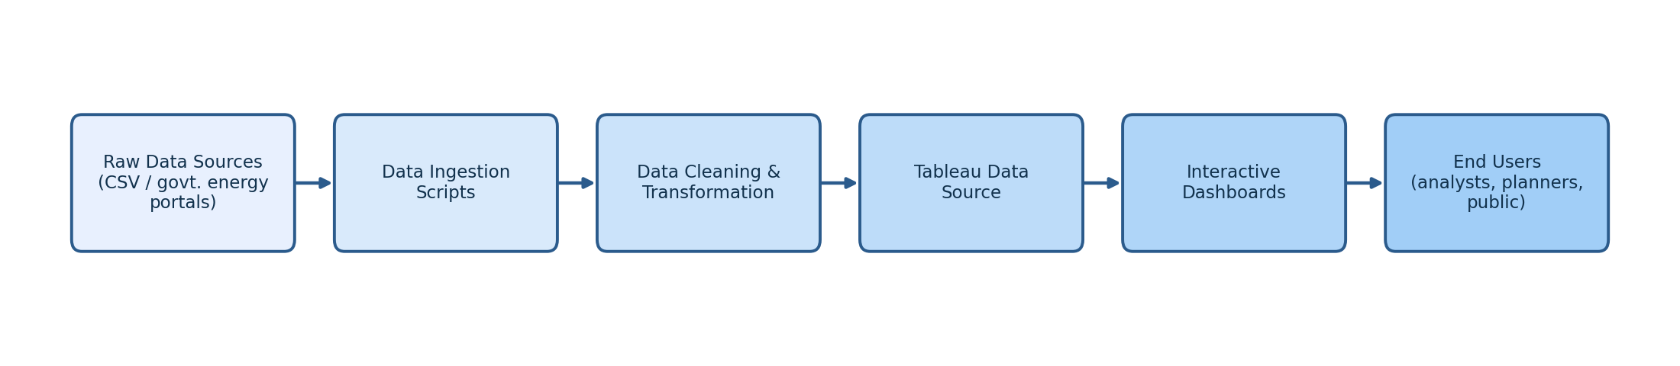
User Stories
User Type | Functional Requirement | USN | User Story / Task | Acceptance Criteria | Priority | Release
Energy Analyst | Registration | USN-1 | As a user, I can register for the application by entering my email, password, and confirming my password. | I can access my account / dashboard | High | Sprint-1
Energy Analyst | Registration | USN-2 | As a user, I will receive a confirmation email once I have registered. | I receive a confirmation email and can click confirm | High | Sprint-1
Energy Analyst | Login | USN-3 | As a user, I can log into the application by entering email & password. | I can access the dashboard after correct login | High | Sprint-1
Energy Analyst | Dashboard | USN-4 | As a user, I can view monthly and seasonal electricity consumption trends. | I can see curated trend charts by month/season | High | Sprint-2
Energy Analyst | Regional Comparison | USN-5 | As a user, I can filter and compare consumption across states/regions. | Filtered charts update by region selection | High | Sprint-2
Web User | Report Export | USN-6 | As a user, I can export a chart or summary as a report. | Downloaded report matches on-screen view | Medium | Sprint-3
Support Executive | Query Handling | USN-7 | As a support exec, I can view and reply to user queries submitted through the contact form. | I can reply to inquiries and see resolution status | Medium | Sprint-3
Administrator | Data Management | USN-8 | As an admin, I can upload/update the electricity consumption dataset. | Dashboard reflects updated data after refresh | High | Sprint-2

3.4 Technology Stack
S.No | Component | Description | Technology
1 | User Interface | How the user interacts with dashboards (Web UI) | Tableau Public / Tableau Desktop
2 | Data Processing | Cleaning, transforming and structuring raw data | Python (Pandas), Excel
3 | Database | Storage of the processed dataset | CSV / MySQL
4 | Visualization Engine | Rendering interactive charts, maps, and dashboards | Tableau
5 | Hosting | Publishing dashboards for public access | Tableau Public
6 | Version Control | Tracking project files and documentation | GitHub

4. Project Design

4.1 Problem–Solution Fit
The Problem–Solution Fit identifies that stakeholders face a real problem — fragmented, hard-to-interpret electricity consumption data — and confirms that an interactive Tableau dashboard genuinely solves it by consolidating trends, regional comparisons, and seasonal patterns into one accessible view.
1. Customer Segment(s)  Energy analysts, utility planners, and policy researchers needing clear consumption insights | 6. Customer Constraints  Budget for enterprise BI tools; limited technical/coding skills; internet access for cloud dashboards | 5. Available Solutions  Manual spreadsheet analysis; government static reports; costly enterprise BI suites
2. Jobs-to-be-Done / Problems  Spotting seasonal demand peaks; comparing states/regions; tracking year-over-year growth | 9. Problem Root Cause  Consumption data is scattered across raw files with no unified, visual way to compare trends | 7. Behaviour  Downloading raw reports; building manual spreadsheet charts; reading news/government summaries
3. Triggers  Preparing a planning report; noticing an unexplained demand spike in the news | 10. Your Solution  An interactive Tableau dashboard that visualizes monthly, seasonal, and regional electricity consumption patterns | 8. Channels of Behaviour  Online: browsing dashboards and reports. Offline: planning meetings, policy briefings
4. Emotions: Before / After
Before: overwhelmed, uncertain → After: confident, informed

4.2 Proposed Solution
S.No | Parameter | Description
1 | Problem Statement | Utilities and analysts lack a data-driven, visual way to understand evolving electricity consumption patterns across time and regions, often missing timely insight needed for grid planning and policy decisions.
2 | Idea / Solution Description | This project uses Tableau to analyze and visualize electricity consumption trends. By leveraging real-world consumption datasets, it highlights monthly patterns, seasonal peaks, and state-wise demand. Dashboards enable stakeholders to make strategic decisions regarding grid capacity, demand-side management, and energy policy.
3 | Novelty / Uniqueness | Unlike static government reports, this project combines time-series trend analysis, geographic comparison, and seasonal pattern detection into a single interactive platform, offering a holistic view for both technical and non-technical stakeholders.
4 | Social Impact | The solution supports more efficient energy distribution and demand forecasting, helping reduce blackout risk and supporting the transition toward sustainable, well-planned power grids.
5 | Business Model | The solution can be offered as a B2B/B2G analytics service where utilities and government bodies subscribe for dashboard access, with additional revenue from custom reports and consulting.
6 | Scalability | The framework can be extended across countries, integrated with real-time smart-meter feeds, and applied to related domains such as water or gas consumption analytics.

4.3 Solution Architecture
The solution architecture describes how data flows from source to insight:
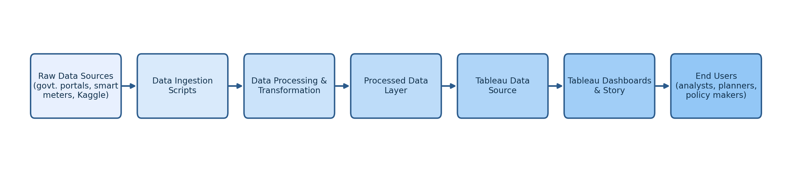
Raw Data Sources (Government energy portals, smart-meter exports, Kaggle datasets) → Data Ingestion Scripts → Data Processing & Transformation (cleaning, unit standardization, feature engineering) → Processed Data Layer → Tableau Data Source → Tableau Dashboards & Story → End Users (analysts, planners, policy makers, the public).

5. Project Planning & Scheduling

5.1 Project Planning
Product Backlog and Sprint Schedule
Sprint | Functional Requirement | USN | User Story / Task | Story Points | Priority
Sprint-1 | Dashboard | USN-1 | As a user, I can view key electricity consumption metrics on the dashboard. | 5 | High
Sprint-1 | Data Filtering | USN-2 | As a user, I can filter consumption data by state and month. | 6 | High
Sprint-1 | Data Upload | USN-3 | As an admin, I can upload electricity consumption data. | 4 | Low
Sprint-1 | User Profile Setup | USN-4 | As a user, I can create and edit my analyst profile. | 5 | Medium
Sprint-2 | Seasonal Trend Analysis | USN-5 | As a user, I receive insights on seasonal consumption peaks. | 8 | High
Sprint-2 | Regional Insights | USN-6 | As a user, I can see top consuming states/regions. | 5 | Medium
Sprint-2 | Ranking Visualization | USN-7 | As a user, I can view state-wise consumption rankings visually. | 7 | Low
Sprint-3 | Year-over-Year Analysis | USN-8 | As a user, I can analyze year-over-year consumption growth. | 6 | High
Sprint-3 | Search | USN-9 | As a user, I can search consumption records by state or month. | 6 | Medium
Sprint-3 | Comparison Tool | USN-10 | As a user, I can compare consumption across states and years. | 8 | Low
Sprint-4 | Export Report | USN-11 | As a user, I can download a personalized consumption report. | 10 | Medium
Sprint-4 | Anomaly Highlighting | USN-12 | As a user, I can view flagged unusual demand spikes or drops. | 10 | High
Project Tracker, Velocity & Burndown
Sprint | Total Story Points | Start Date | End Date (Planned) | Points Completed | Release Date
Sprint-1 | 20 | 01 Jul 2025 | 06 Jul 2025 | 18 | 06 Jul 2025
Sprint-2 | 20 | 07 Jul 2025 | 12 Jul 2025 | 17 | 12 Jul 2025
Sprint-3 | 20 | 13 Jul 2025 | 18 Jul 2025 | 14 | 18 Jul 2025
Sprint-4 | 20 | 19 Jul 2025 | 24 Jul 2025 | 20 | 24 Jul 2025

6. Functional and Performance Testing

6.1 Performance Testing
S.No | Parameter | Details
1 | Data Rendered | The dataset was successfully imported into Tableau. It contains monthly and state-wise attributes such as region, state, month, year, and electricity consumption/power supplied (in million units).
2 | Data Preprocessing | Dataset cleaned and prepared before visualization. Missing values checked and handled (removing empty rows, imputing where appropriate). Duplicate records and inconsistent state names removed for accurate analysis.
3 | Utilization of Filters | State/Region Filter, Month Filter, Year Filter
4 | Calculation Fields Used | Monthly Consumption Total, Average Consumption by Region, Year-over-Year Growth %, Peak Month Indicator
5 | Dashboard Design | No. of Visualizations / Graphs — 8: Monthly Consumption Trend, State-wise Consumption Map, Top Consuming States, Consumption by Region, Seasonal Peak Analysis, Year-over-Year Growth, Peak vs. Off-Peak Comparison, Consumption Distribution by Month
6 | Story Design | No. of Visualizations / Graphs — 5: National Trend Overview, Regional Comparison, Seasonal Peaks, State Rankings, Year-over-Year Growth

7. Results

7.1 Output Screenshots
Dashboard 1 — "Monthly Electricity Consumption Overview" presents the total monthly consumption trend for the selected year alongside a breakdown by region, allowing users to immediately spot seasonal peaks (typically summer and winter months) and troughs.
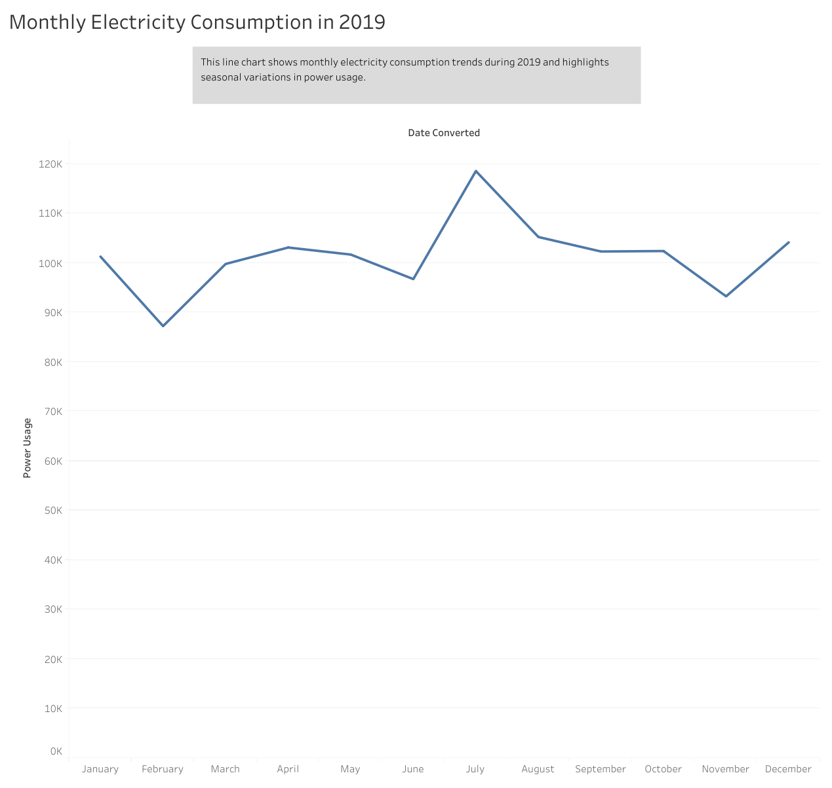
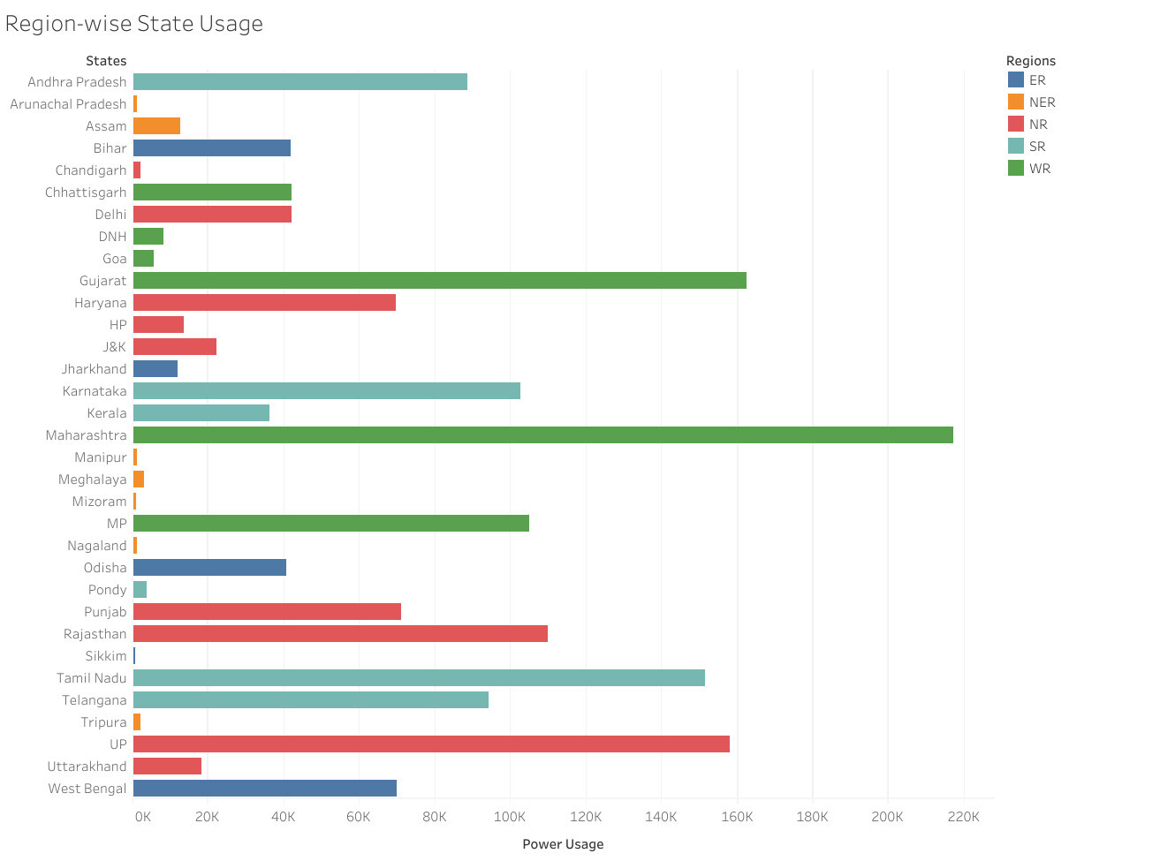
Dashboard 2 — "State-wise Consumption Comparison" uses a geographic heatmap and ranked bar chart to show which states/regions consume the most electricity, supporting regional planning and equitable resource allocation.
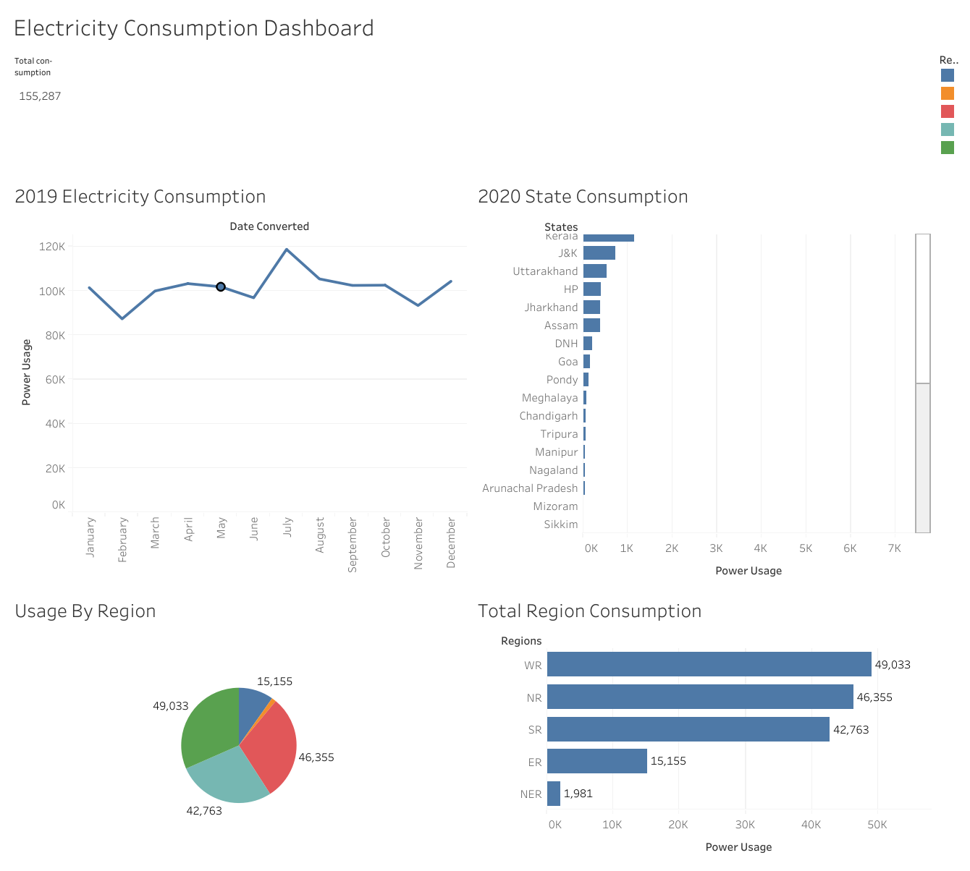
Story — "Understanding Electricity Consumption Patterns" walks the viewer through national trends, regional comparisons, seasonal peaks, and year-over-year growth in a guided narrative, making the insights accessible to non-technical stakeholders.
Note: this report references the published Tableau workbook "Monthly Electricity Consumption in 2019," part of the Electricity Consumption Analysis project on Tableau Public. Specific screenshots and the underlying processed dataset should be inserted here from the project’s GitHub repository and Tableau Public workbook once available for direct embedding.

8. Advantages & Disadvantages

8.1 Advantages
- Data-Driven Decision Making: Enables stakeholders to make informed grid and policy decisions based on real-time data insights.
- Interactive Dashboards: Tableau dashboards provide dynamic visualizations that allow users to explore consumption data in a user-friendly manner.
- Improved Demand Understanding: Helps identify seasonal peaks, regional disparities, and growth trends in electricity usage.
- Supports Grid Planning: Insights can guide capacity planning and demand-side management strategies.
- Time Efficiency: Reduces the time needed to interpret large consumption datasets by converting them into intuitive visuals.
- Scalability: Dashboards can be updated with new data to reflect current trends without reworking the entire project.

8.2 Disadvantages
- Data Dependency: The quality of insights is limited by the quality and completeness of the underlying consumption dataset.
- Tool Limitations: Tableau Public has feature limitations compared to the paid version (e.g., data refresh, privacy controls).
- Learning Curve: New users may require time to understand and navigate Tableau's interface effectively.
- Limited Predictive Capabilities: Basic dashboards focus on descriptive analytics; forecasting requires integration with additional tools.
- Internet Requirement: Access to dashboards hosted on Tableau Public or cloud services requires a stable internet connection.

9. Conclusion
The project "Plugging into the Future: An Exploration of Electricity Consumption Patterns" demonstrates the powerful role of data visualization in understanding and responding to electricity demand. As energy needs continue to grow and diversify, utilities and policy makers are under increasing pressure to plan capacity, manage seasonal peaks, and support sustainable growth. This project addresses these challenges by transforming raw, complex consumption data into visually appealing and interactive dashboards using Tableau.
By analyzing dimensions such as monthly trends, regional demand, and year-over-year growth, the project provides a comprehensive view of consumption dynamics. These insights help stakeholders make informed decisions related to grid planning, demand-side management, and energy policy. The visualizations created allow users to identify trends, spot seasonal patterns, and extract valuable information without needing advanced technical skills.
Additionally, the project emphasizes the importance of real-time analytics and interactive tools in supporting agile energy planning. Whether monitoring a sudden demand spike, addressing regional supply gaps, or identifying emerging seasonal trends, the dashboards serve as a reliable tool for both strategic and operational decision-making.
In conclusion, this project successfully showcases how tools like Tableau can bridge the gap between electricity data and decision-making. It lays a strong foundation for future enhancements, such as incorporating predictive analytics, expanding datasets to include real-time smart-meter feeds, or integrating renewable energy generation data.

10. Future Scope
- Integration with Real-Time Data Sources: Incorporating live feeds from smart meters or grid operators can enable real-time demand monitoring and faster response to shifts.
- Predictive Analytics and Machine Learning: Adding forecasting models can help predict future consumption and support proactive grid capacity planning.
- Renewable Energy Integration Analysis: Extending the dashboard to compare consumption against renewable generation to assess grid balance.
- Mobile-Friendly Dashboards: Optimizing dashboards for mobile and tablet views to improve accessibility for field staff and planners.
- Integration with External APIs: Connecting with weather APIs to correlate temperature extremes with demand spikes.
- Enhanced Security and Data Privacy: Implementing stronger access controls as more granular, potentially sensitive consumption data is integrated.
- Expansion to Other Utilities: The model can be extended to water and gas consumption analytics for a broader utility insights platform.

11. Appendix
Dataset Reference
The project workbook "Monthly Electricity Consumption in 2019" aligns with publicly available state-wise electricity consumption data for India, such as the Kaggle dataset "Power Consumption in India (2019–2020)" (kaggle.com/datasets/twinkle0705/state-wise-power-consumption-in-india). Please confirm or replace with the exact dataset used in your GitHub repository so this section can be finalized precisely.
GitHub Repository
github.com/Dharshini025/An-Exploration-of-Electricity-Consumption-Patterns
Tableau Public Workbook
Electricity Consumption Analysis – Monthly Electricity Consumption in 2019 (Tableau Public)

